MasterMind
HPA-OverWacth Authorization

In order to use the HPA-OverWatch Expert Advisor (E.A.), you must be current with your MasterMind subscription and you must follow the below steps to authorize the E.A. prior to use.

Basically, you will obtain a token from your profile and then enter your current account number into your profile. You may enter more than one account number.

- Obtain Token
  - Go to your profile at: https://daytradesmart.com/members/profile/<user>/?profiletab=main
    - Replace ‘<user>’ with your MasterMinde user
  - Click ‘App Token’ tab and note your token/code
  - 
- Enter Token into MT4
  - Open MT4 and click ‘Tools -> Global Variables’ or press F3
    - A new dialog will open, click ‘Add’
    - Enter ‘MMAppToken’ under the ‘Variable’ column and your token, as noted in section 1.b, in ‘Value’ column
  - 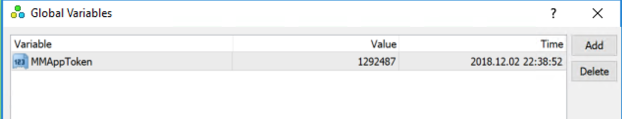
- Obtain MT4 Account Number
  - Open MT4
  - Look in the Navigator
  - 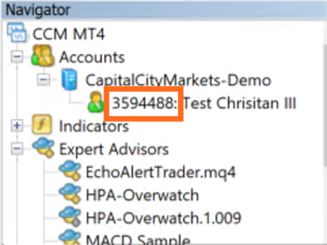
- Enter MT4 Account number into your DayTradeSmart.com profile
  - See 1.a to get to your profile page
  - Click the ‘gear’ then ‘Edit Profile’
  - 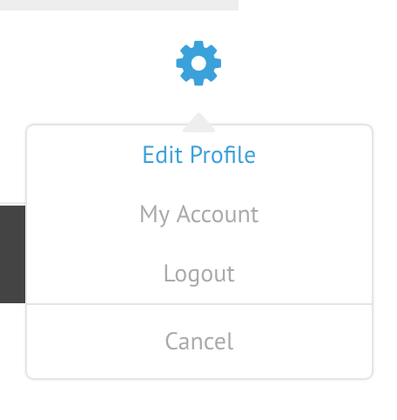
  - Enter your account number, you may enter more then one serrated by commas, then ‘Update Profile’:
  - 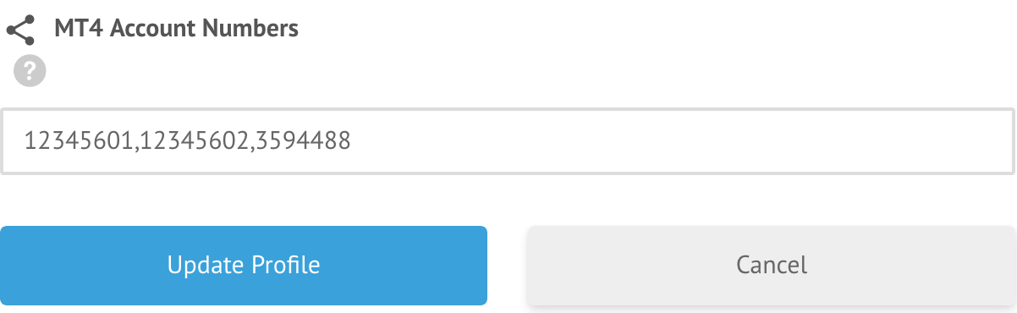
- Enable web calls to daytradesmart.com in MT4
  - Open MT4
  - Click ‘Tools->Options’ and click the ‘Expert Advisor’ Tab
  - Check the box ‘Allow WebRequests for listed URL’
  - The click the green plus icon bellow and enter the following URL
    - https://daytradesmart.com
  - Then click OK
  - 